Easy Ways to Help the LG!

Here are some easy ways to support the LG Nourse School. Please spread the word to neighbors or family members. The more support we have, the more cash/points we get to purchase things for the kids!

Box Tops for Education
Box Tops for Education are on numerous products so clip them and save them for the LG. You send them into to school with any child that attends the LG. Or you can drop them off at the school. For a full listing of products go to www.boxtops4education.com.
BONUS through September 30th!! Sign up for the Box Tops Newsletter on their website and the LG will get 5 bonus box tops for FREE! The website also offers high value coupons for items and offer contests where you can enter to win bonus point for the LG.
Box Tops for Education also has a Facebook page. Like it and they tell you about chances to win bonus points.

** There are incentives for the class that brings in the most Box Tops and Labels of Education combined each month. That class gets an extra choice time or recess. Please don't forget that the Goldfish bar code count too.

Labels for Education
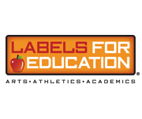
Labels for Education is a fun and easy program where families and members of the community work together to “Earn Free Stuff” for their school! Collect these UPCs and caps for a huge list of participating products. Once again, send them to school with your student or you can drop them off at the school. Every label turned in earns points that can be redeemed for Arts, Athletics, and Academics merchandise.
For a full listing of participating production go to www.labelsforeducation.com. Labels for Education also has a Facebook page. Like it and they tell you about chances to win bonus points.
BONUS now through October 9, 2015! Go to their website and enter to win by clicking on Grand Stand for Schools Logo. You just have to enter your contact information after signing up for the website and each time counts as an entry to win. NO purchase necessary!

Target
If you have a Target credit or debit card, every time you shop and use that card, the LG will earn cash. Go to the Target website, www.target.com (have with your card as you need to enter your account number) and click on the “Red Card,” from there, click on “Take Charge of Education.” Enter your information and designate the LG Nourse School as your school of choice. For each purchase you make on your Target Debit or Credit Card or Target Visa Card, the LG will earn 1% of that total.

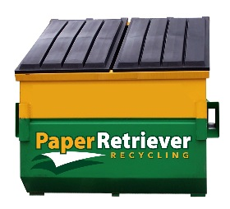
Recycling
Help your organization. Help the environment. When you drop off your recyclable paper in a Paper Retriever bin, your organization gets paid cash. The LG’s PaperRetriever.com yellow and green recycling bin on the side of the building (the road side in the parking lot).
The bin accepts newspapers, magazines, office and school papers, catalogs and mail. It does NOT accept cardboard or phone books. It does however, accept shredded paper. Just put it in a closed plastic bag (trash bag tied) and drop in the big bin!

Bay State Textiles
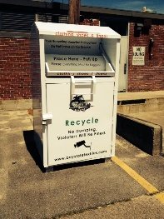
Every year 21 BILLION pounds of textiles are thrown away in the United States and Norton has partnered with Bay State Textiles to help recycle and reuse. They accept donations of clothing, shoes, linens, and even stuffed animals in any condition as long as it’s clean and dry! Please check their website (baystatetextiles.com for the listing of acceptable items. It’s amazing what they can use!

Hannaford Helps Schools
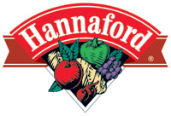
To participate just look for specially marked brands and purchase 4 of those items to get 3 school dollars. The cashier will hand you a slip with your receipt that you then place in the LG Nourse slot on the tall tower by the windows. For a listing of products go to www.hannaford.com, then to the “About Us” tab and then to the “Community” tab.
The program runs from end of August through the beginning of December 2015.

Stop N Shop A+ School Rewards
A+ School Rewards are points that supporters earn with each purchase made using their Stop & Shop Card. At the end of each month, the points earned are used in a calculation to determine your school's cash total, which is then automatically credited to your school's account. Customers can support up to two schools to benefit from their A+ School Rewards that accrue. Got to Stopandshop.com, then to the “My Stop and Shop Card,” once there look for the A+ link on the left side and sign in. You will need your Stop N Shop card when registering. Look us up by name or use our ID # 07468.
The program runs from October 9, 2015 to March 17, 2016 and earns the school CASH!

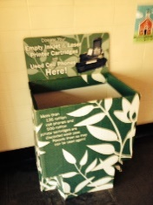
Cell Phone and Printer Ink Cartridge Donating
Old cell phones and used ink printer cartridges (inkjet or Laser) can be turning in to the box in the lobby. The school then turns them in and receives cash for the school.

